CPR Direct PNR Lookup
Installation and operation instructions
For CPR client

24. April 2003

Introduction
CPR client must be installed and run on a PC or Server with an Intel or compatible processor and operating system windows 95/98/NT/2000. There must be TCP / IP connection to the client applications as well as CPR system.
Seen in relation to the central system, CPR is a CPR Direct Client TCP/IP CLIENT.
Seen in relation to the customer administrative system, CPR is a Direct Client TCP/IP SERVER

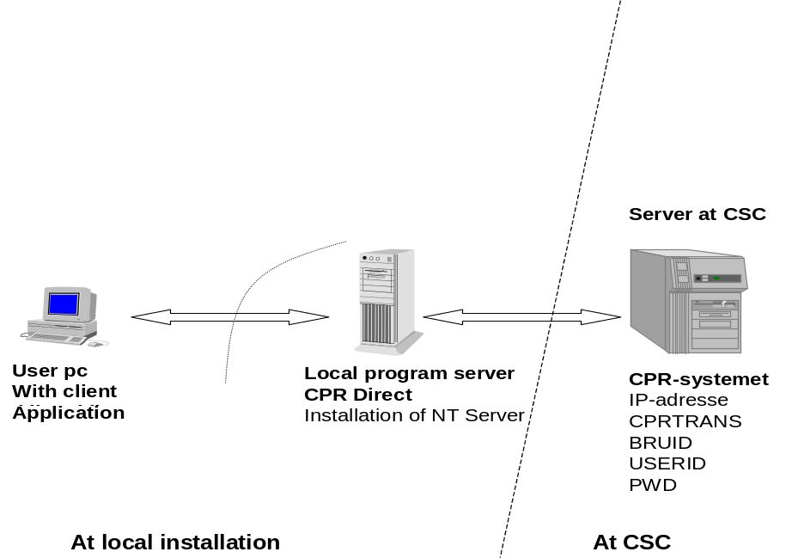

Figure 1. Configuration Drawing for CPR Direct.

Ingredients
CPR Direct client consists of the following files:
CPRDIRSRV.EXEThe CPR client program.
SVCCPR.EXEProgram for the creation of the CPR as a client service.

The program requires the VB5 runtime files, and MSWINSCK.OCX component is installed on the machine where CPRDIRSRV.EXE up. These components will be installed by the included setup programs.
In addition, the product of this installation and operating instructions, and the specific description of the CPR Direct application.

Installation and setup

Installing the program CPRDirSrv.exe
Installation can be done on any PC or server which is on the network and may reach the CPR system, which runs operations at CSC.
The program sent in an e-mail, as a self-extracting file:
DETACH CprDirekte_V180.xee file from e-mail and upload it to eg. the local c drive.
Rename the file from CprDirekte_V180.xee to CprDirekte_V180.exe.
In Explorer double-click the file CprDirekte_V180.exe and it specifies the directory where you want the setup directory created (eg. CPR_direkte_setup)
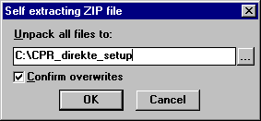

The program CprDirSrv.exe installed by running setup.exe from the selected library, thereby taking off 2 windows pop up.

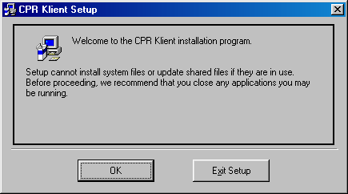

Press OK to continue

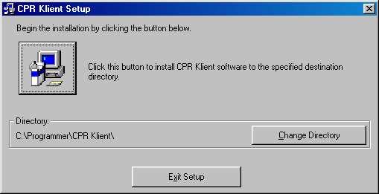
1. Select 'Change Directory' if another installation directory 'wishes
2. Press the computer icon to perform the installation.

Contents of the libraries after installation is run
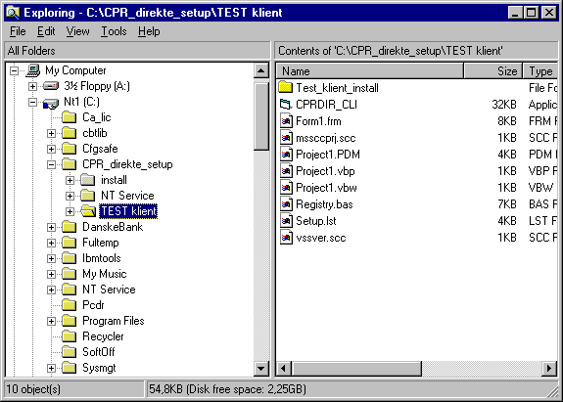

The folder 'Test Client' includes a testing and source code to test the program.

Create a shortcut to CPRDIR_CLI.exe (test client).

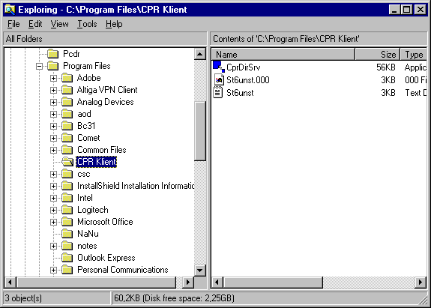

Create a shortcut to CprDirSrv.exe.

3.2 Setting up the program CPRDirSrv.exe
The setup must be started and is using the 3 items under the main menu item setup as shown in the following figure:

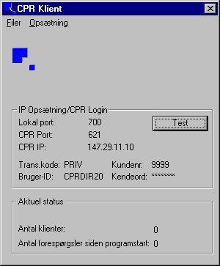

    - Configuring TCP / IP address from CPR
Select the menu item TCP / IP ... thereby taking off window appears:

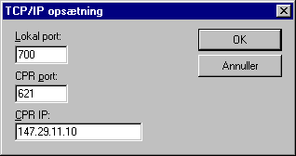

CPR IP field:
In the box is indicated as 147.29.11.10 both to be called from CPR's DEMO system (used for testing) and when run against CPR's prod system.
CPR port:
In the box indicated 621 when to run against CPR's DEMO system 620 when run against CPR's prod system.
Local Port:
The port number used for TCP / IP traffic between the customer administrative systems and CPRDirSrv program. Choose a port number as not conflicts with the organization's other programs.
Program CPRDirSrv listens on local port to disseminate CPR data requisition from the customer administrative systems.

    - Set up customer
Select the menu under the Customer-level window appears:
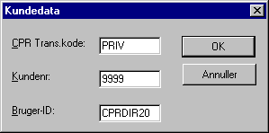

CPR Trans.kode field:
Must be completed with the CPR office reported transaction code.

Customer number field:
In the box indicate the CPR office assigned customer number.

User ID field:
In the box indicated by the CPR office assigned user code.

    - Configuring kendeord (password) to the CPR
Select the menu item Kendeord thereby taking off window appears:

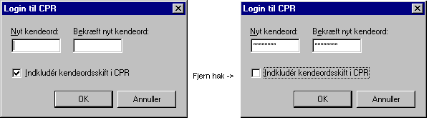
Fill in both the "New kendeord" and "Confirm new kendeord" with the CPR office assigned kendeord andDistance"Checkmark" in the "Include know the word shift in CPR." These operations result is that the client will have saved the allotted kendeord without knowing the word changed in the central CPR system.

3.3 Test against CPR
After installation and setup of CPR Client is finished, there may be a test against CPR's DEMO system.
Customizing CPR client, so the IP address of the CPR's host is 147.29.11.10 and the port number is 621
Test komunikationen between CPR Direct and CPR System by pressing the "Test" button. See figure below.

The first four characters in the response CPR indicates customer number here'9999 '. The position 15-22 is the the User ID, here 'CPRDIR20'. The next 2 positions contain error code from the CPR Direct. If, as this return with "00" in the two characters is the connection / login in order. They ¤ last 4 characters indicate the length of the answer, here'0028 '.

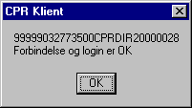
Results of tests of communication with CPR system.

3.3.1 Development and testing of user applications from CPRDirSrv.exe
When testing against CPR is successfully concluded, we can test the communication from program CPRDirSrv with the included test program is developed in MS Visual Basic version 5.0.
Test programs and source code are in separate file during setup directory under \ TEST client \.
Remember that proper IP address to the IP address where the program runs on CPRDirSrv and setup port number to the same port number as a local port
TEST program can run on the same machine as CPRDirSrv.exe or on another machine in the network.
For developing their own applications made to the specific description of the CPR Direct application.

3.3.2 VB template program included
VB source code included for test programs and may copied and used as template in developing their own systems to 'download' CPR data.

3.4 Production
When the test is completed successfully, the CPR directly put into production in agreement with the CPR Office.
Before production, the customer production IP address to be commissioned in CPR. Then adapted CPR client so that it communicates with CPR's production system to the IP address 147.29.11.10 and port number 620
Then the client side of CPR Live ready for use. There can be run production, where also the central server is ready.

Operation
CPR CPRDIRSRV.EXE Client program can either run as a regular program with a visual user interface, or under Windows NT/2000 operating system as an NT service, the program is not visible and otherwise up-and closed automatically with the machine.
Completion of CPR Direct Client by ordinary program
The former option is used in the configuration / modification of the driving parameters. With the exception of kendeord this information could also be changed in the registry under [HKEY_LOCAL_MACHINE \ SOFTWARE \ CSC Danmark A / S \ CPR Direct].
Know the word for CPR is also here, but in encrypted form.
Change of CPR kendeord
The image from which kendeord changed, can either be used to indicate an existing and valid kendeord for CPR or the modification of kendeord in CPR.
Expression of an existing one used in the initial setup of CPR Direct. "Chop" by "Indkludér know the word shift in CPR" was removed. It was thus possible to indicate the assigned kendeord of CPR without changing the CPR system records.
The rules for kendeord is that they must be 8 characters and consist of both numbers and letters (capital letters). It is not allowed to switch to a kendeord that has been used.
Changing kendeord relevant, for example by starting the production system or when it expires in CPR's Safety (validity period is currently 90 days) Or if you otherwise want to change it. In these situations the set "checkmark" in the "Indkludér know the word shift in CPR." Click OK now involves modification of known word in the CPR system.
Completion of CPR Direct as NT service
- Close possibly ride version of CPR Direct.
- Open the registry and create the following key and data under [HKEY_LOCAL_MACHINE \ SOFTWARE \ CSC Danmark A / S \ CPR Direct]
String Value: AppPath Value: Path to CPRDirSrv.exe example C: \ Program Files \ CPR Direct. Run the supplied service program SVCCPR.EXE with parameter INSTALL to install Direct CPR as NT Service.
- Start the Service Manager in the Control Panel and enter the startup parameters of CPR Service Direct.
- Start the service.

